

Francis Hamilton

Aldo Renz

Zhang Ge

Chen Yingjie

Koichiro Tamura

Final Business Plan

Group E

University of Tokyo

Contents

1. Introduction 3

2. Description of the Technology 3

3. Description of our product (Wireless Socket) 3

3.1 Inside Wall Emitter (Primary Coil): 4

3.2 Outside Wireless Socket Secondary Coil): 4

4. Customer segment 5

4.1 Segment Dimensions 5

4.2 Problems, needs, habits, current alternatives 5

5 Competitor Analysis 6

6. Market Analyzes 7

6.1 Market Size 7

6.2 How to approach and take the market 9

7. Value Propostion 10

8. Customer Relationship: 12

9. Key resources: 13

9.1 Product: 13

9.2 Source: 13

9.3 Infrastructure: 13

10. Revenue: 13

11. Costs 14

11.1 Cost of goods sold 14

11.2 Operating expense 14

11.3 Net income 14

12. Key partners: 15

13. Regulations: 16

# 1. Introduction

Since the dawn of time humans have been inventing new technologies in which further the development and ease of living for human life. The world is changing to incorporating more technology into things people use everyday. There are many opportunities within this expanding market of smart technology. Our product falls within this scope whereby it does not solve a problem but further improves upon it. Through fairly recent technology developed at the University of Tokyo we propose a Wireless Wall Socket with adaptor extensions. The content of the business proposal will illustrate how this technology improves humans daily lives and how it can be applied to a wide variety of markets.

Firstly a description of the technology and how the product uses this technology will be outlined. Following this, the different customer segments are shown. Then the possible competitors are highlighted. Following this, the market penetration and customer acquisition methods are proposed. Finally, the cost and revenue streams are outlined.

# 2. Description of the Technology

Inductive charging is not a new idea at all. Nikola Tesla worked out the basic principles which apply to the technology that has been implemented at the University of Tokyo. Inductive coupling is when a AC current in coil generates a varying magnetic flux which induces an AC current in the second coil. Electrical transformers utilize the same idea except with a core between the two coils which improves the flux transmittance. There are several drawbacks to this principle such as the coil separation generally needs to be less than 10 cm.

Over the last decade researchers have discovered that if the coils operate at the resonance frequency of the two coils which is calculated by the permittivity of the material, capacitance etc. The power transfer significantly increases between the two coils thus allowing the separation distance to increase. The technology is quite complex and would be out of the scope of the readers knowledge. It basically utilises energy tunnels which flow from one coil to the other instead of the in the omnidirectional case. The drawbacks of this type of technology is that it is extremely more complicated, for operating at resonance quite a few conditions need to be met including the coil diameter to separation distance and for the coils to be aligned for maximum efficiency.

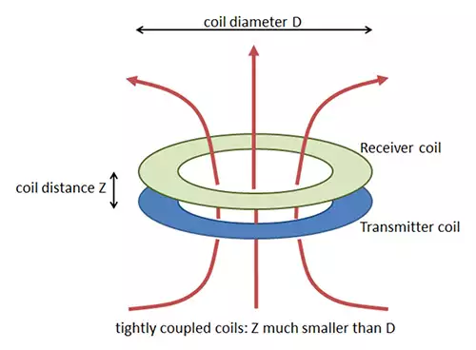

# 3. Description of our product (Wireless Socket)

The product is geared towards improving the ease of life for the modern consumer. The pain of the consumer can be described in two-fold and thus the realization of the product is better understood. Firstly, everyone knows the problem that power outlets are never at the place they are needed, or they are covered after the repositioning of furniture. Moreover, when planning a new home or flat people suffer by the decision where to locate the power outlets. Also, when planning a new office, the decision makers can’t know how the office will look like in 10 or 20 years. Moreover, companies and people want to change or are forced to change the setup of their facilities. With our product they can freely move their machines or furniture without considering the locations of power outlets. These reduces the hesitation for change, especially for private homeowners.

Secondly, the idea of the an adapter plug has long been in existence for travelers. However, purchasing an adapter often is costly as they vary for each country and as well as they are normally only for one output socket. It would be a lot for convenient if say your cellphone charger not only could be placed around your room but also in your friends room overseas. The world is getting smaller with more and more people being able to travel there needs to be easier methods for transitioning between your home and everywhere else in terms of electronics.

There is not a need for these consumer pains listed above to be removed but an ease of comfort provided to the consumer if these pains were solved.

## 3.1 Inside Wall Emitter (Primary Coil):

By having an array of primary coils running the length of the wall whereby sockets are wanted. This allows the primary coil’s flux to be transferred from the wall to the secondary coil on the other side of the wall. See figures below: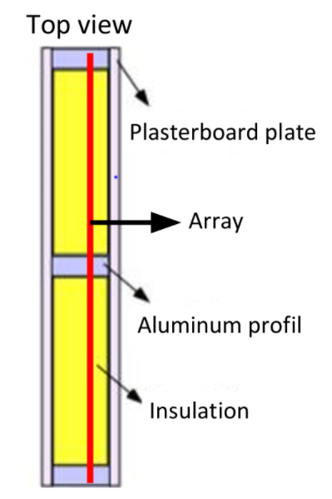

The yellow line running through the blue primary coils is a permanent magnet.

## 3.2 Outside Wireless Socket Secondary Coil)**:**

The socket will vary in design as it can be made for many applications. Whether you would just like a normal outlet on the other side for your microwave or if you have a wireless socket that has a micro USB charging cable output. However, each socket regardless of cable output will be a standard square with a metal rim on the wall side so it will remain in place on the wall emitter array.

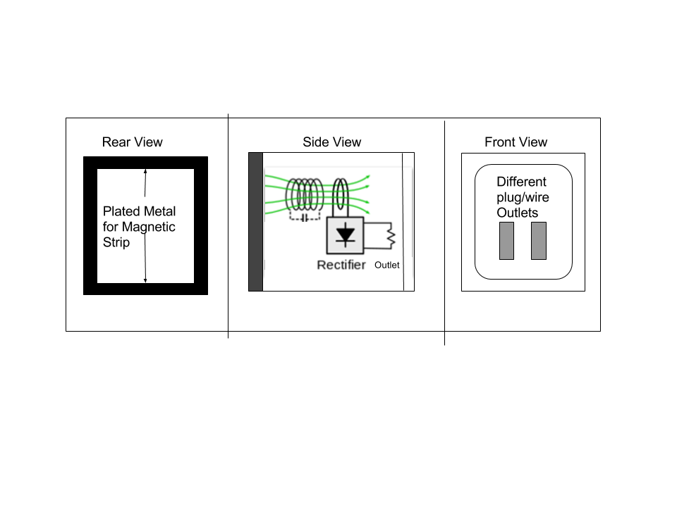

# 4. Customer segment

## 4.1 Segment Dimensions

For our product we have an multi sided market. We have different customers one the hand our main customers are architects, electricians and construction firms which use our product to create a higher value for the customers. Moreover, they can provide a unique solution to the customers by using our product. This would be a business to business (B2B) relationship, because the involved stakeholders are not the final consumer of the product. Another customer segment are companies how want to build a new facility or people who want to buy new flat and or want to build a house. The third segment are owners who want to make an overall renovation to the properties. In this case it would be a business to consumer (B2C) relationship. Our main segment will be the architects, electricians and the construction firms because they will have the biggest margins of all possible customers. We will put the highest emphasis on this segment in the following parts.

## 4.2 Problems, needs, habits, current alternatives

Our product addresses various problems of customers. The need of flexibility is increasing in every part of society, also in the construction sector. Moreover, this sector is one of a very competitive nature. With our product the architects, electricians or construction companies have a great advantage over their competitors who only can provide a conventional solution. The advantageous differ to the clients of the before mentioned stakeholders. If the clients is someone who wants to build a new office building has now various options to create a more flexible environment with constant power outlet supply. If the client is someone who wants to build a new home, he doesn’t have to decide in the planning phase where the power outlets should be. This reduces the stress because it can reduce decisions to be made in an early phase of the project. Also, the power outlet location doesn’t influence the decisions which have to be made about the kitchen or other parts of the house. Moreover, the system provides more flexibility after it is installed. The rearrangement of furniture gets way easier as the clients don’t have to consider the location of the power outlets anymore.

# 5 Competitor Analysis

There are two companies, Eubiq and Mainline that can be regarded as our direct competitors. They both provide very similar products which is a charging bar that allows you to add, move and reposition the outlets anywhere along the bar.

The price of Mainline’s power track is USD 140 per meter, while the price of Eubiq’s power track is USD 340 per meter. According to data and information collected from our products’ life cycle stages, the estimated price of our wireless sockets is USD 450 per meter. Although we can’t compete in price due to the wireless power transmission technology used in our products, we offer other advantages over our competitors’ products. As for the installation, the track itself can be installed by any electrician who read our product manual, because obviously it is an electrical product. It can be embedded inside the wall. So it does not consume extra space.

As for compliance and safety standards, of course our products have to conform to text specification or safety standard. Eubiq and Mainline products are designed to meet essential safety standards in countries where products are sold. No electric shock will happen because you will not touch the any live conductors. Our product is a safe and childproof product.

The feasibility means not only having the incoming of 220 voltage, but also having the feasibility of 110 voltage on the other portion of the charging system. This can only be achieved in our products because we use a more advanced technology which enables the energy transmission happens in form of electric to magnetic to electric.

Eubiq offers three years products warranty for power tracks and one year for accessories and adaptors. Mainline offers one-year products warranty against for manufacturing defects.

As for multipurpose, Mainline also provide network and USB access in their sockets.

When it comes to flexibility, both Mainline and Eubiq power track allows you to add, remove and reposition power outlets. However, you have to push in an adaptor, turn clockwise fully until you hear a “tick”, and then power adaptor is connected and powered. Our product allows you to operate more easily without the limitation of power track. You can just put the socket anywhere within the magnetic area. Additional operation such as twist is not necessary because the socket can attach by magnetic connection to the wall.

As for design compatibility, both Mainline and Eubiq only provide socket with one two-pole or three-pole jack. If you want to charge for 5 electrical appliances, 5 sockets are needed which is a not a small cost. But our socket is designed to integrate at least one two-pole and one three-pole jack together. By this way, we can improve the compatibility for different appliances with variable size of adapters.

In addition to analyze current competitors, it’s important to think about future competitors as well. IKEA is a potential competitor in the future. Actually, they have made the wireless charging system embedded in their furniture such as cabinet, desk and lamp holder. Although this is a different technology, this kind of products represent the trend of a good integration of furniture and charging which .Our advantage over IKEA is that we offer 1mW to 1kW transferrable power. However, IKEA’ product for example RIGGAD lamp only provides 5mW power. It may not be a good choice for those who chase higher charging efficiency.

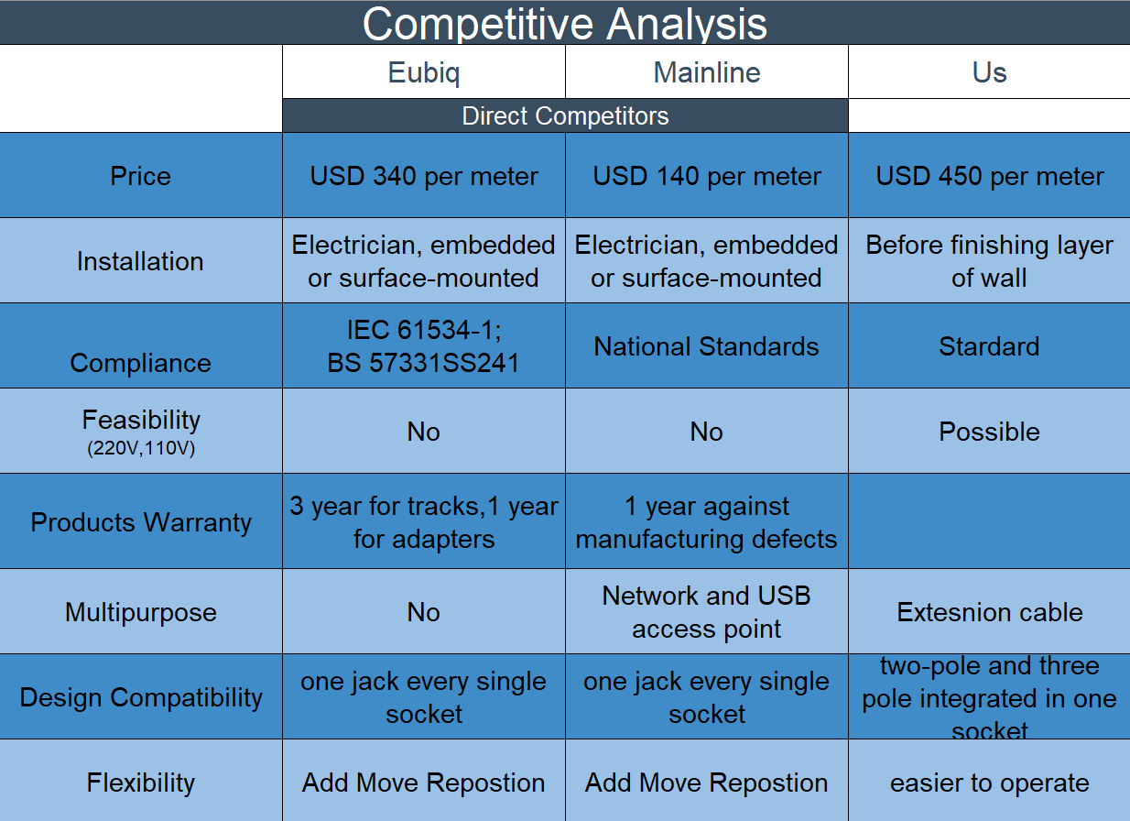

# 6. Market Analyzes

## 6.1 Market Size

First, we discuss the market size we aim to. Since our product is relatively expensive, our targets are high-end customers. For example, people those who care about the design in their house, the start-up companies which would like to use flexible electricity, and hospitals, which use a lot of devices and they need to move them frequently. So when we think about the market size, we have to consider only developed countries.

There are two main sectors as our targets: ‘private sector’ and ‘public sector’. The private sector means residual constructions or private enterprises offices. The public sector means government institutes or hospitals. We estimate the market size of private sector from the data of `new` residual construction. On the other hand, since it is difficult to think that there are lots of new public constructions, we should think that we replace old electronic systems with our product, not introduce it into new buildings.

‘private sector’: Now we can get the information about number of residual constructions in 2016 in developed countries in US, Japan, China, EU, and we add these numbers. The sum of the number of residual is 8,240,000. Of course, there are additional types of constructions like private office. Since we can easily assume that the number of offices are less than one of residual constructions, we consider only the number of new residual constructions. If price of our product is about $5,000/1room and 1% of total new residual constructions potentially introduces our product(high-end customers), the market size (per year) is probably $400 million.

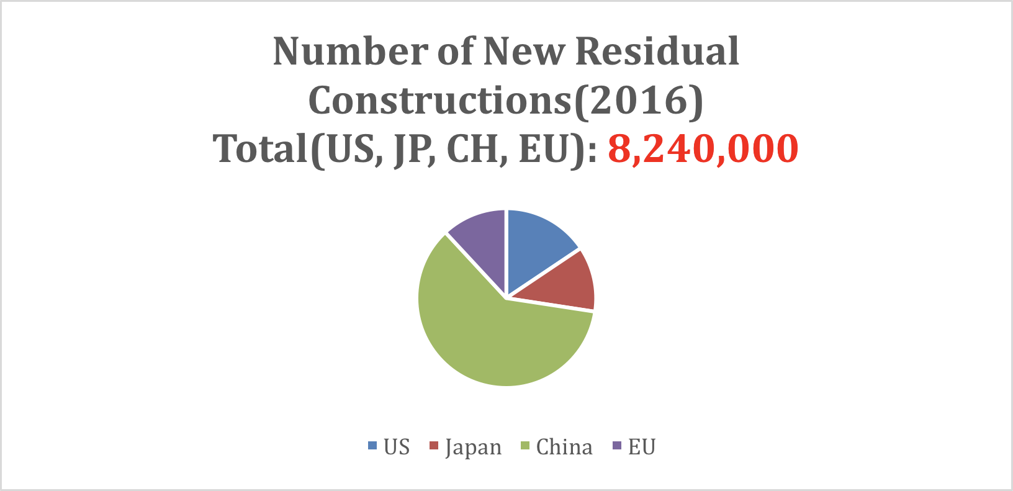

‘Public sector’: Since it is difficult to get the accurate information of the number of public buildings, we consider the number of hospitals to estimate the market size of public sector. According to the statistic information of<https://www.globalnote.jp/post-10233.html>, the number of Japanese hospitals are 8,480, which is the most in the world, and one of America is 5,627, EU is approximately 8,000. There is no data of the number of hospitals in China, but we can easily assume that the number is more than any counties because of its population. We estimate the number of Chinese hospitals is 10,000. The total number of hospitals in the developed counties is about 30,000. When we assume that each hospital has 3 rooms on average and 30% of total hospitals introduce our product, the market size in public sectors is about $135 million.

When we can tell the market size, we consider the market growth. According to Khi group, the construction market growth is as follows.

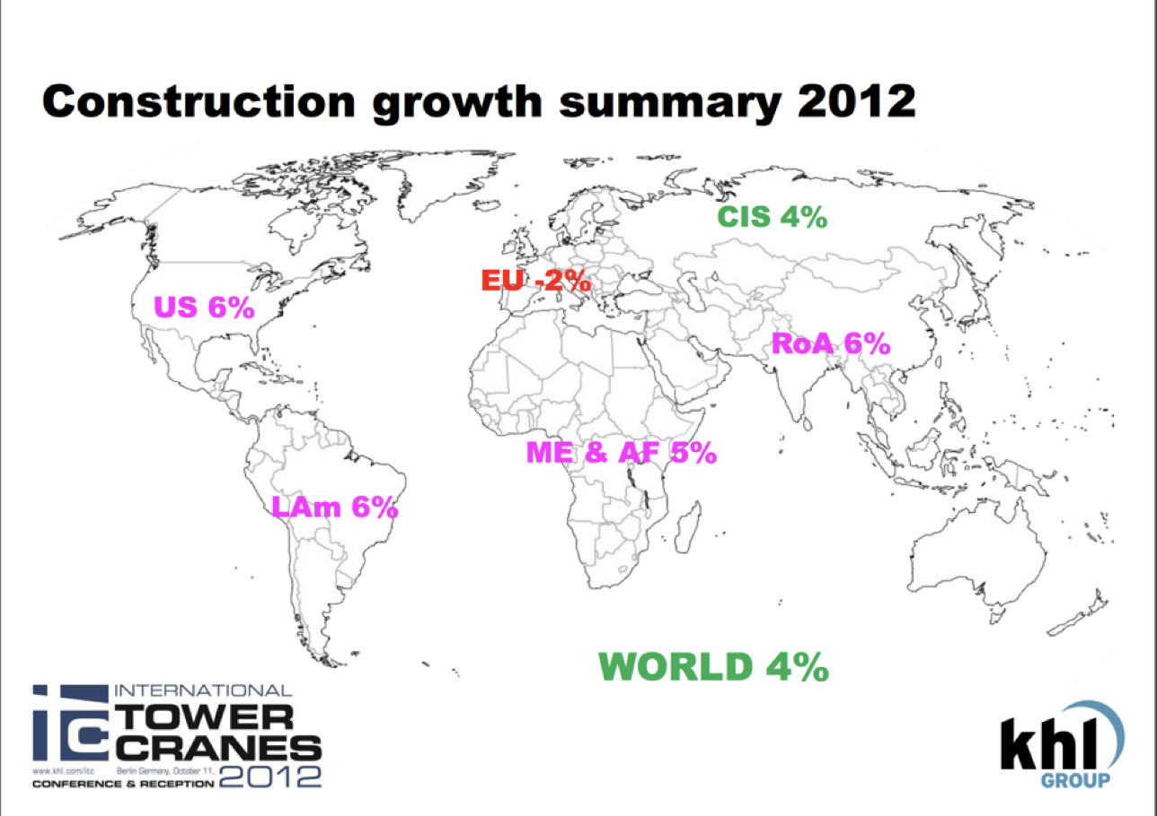

Then we can say the market has been growing.

## 6.2 How to approach and take the market

Next, we consider the way to approach the market. As we mentioned above, our targets are `new` constructions when `private sectors` and `public` institutions which can replace its old electronic system with our product.

We have to say that our product is not easy to install because of its price, Then we should emphasize our advantages of its design or effectiveness. So, first we should aim to the high-end customers like construction designers or cutting-edge hospitals. Since they are different from `mass`, we have to think about the way to pinpoint them as marketing. For example, we participate in the event of designers or use medical media like m3(<https://www.m3.com/> ).

We make the market strategy into three parts:

1.     do collaborative experiments with some construction companies

First, we would like to do collaborative experiments with some construction companies. This means we provide our service for free. By doing this experiments, we can get data and feedback from users and construction companies. When we get enough  data to analyze, we analyze the problems of our services and improve our products and business strategy on the basis of analysis. This strategy is based on Lean Startup, one of the ways of startup strategy. And this part is most important to succeed and we should do this part as quick as possible.

2.      walk in sales to some construction companies or public institutions

our business model is to get the benefit from construction companies or public institutions, not consumers. So we have to walk in sales to those companies and public institutions and persuade them to use our service or product.

3.     hit the advertisement to the general consumers.

Since the end users are the general consumers, not construction companies and public institutions, we should make our product be known by end users. By using the fund we get from the customers (construction companies and public institutions), we hit the advertisements to the general consumers. To do so, the general public knows our service and products, and they think that our new technology is a kind of cool.

# 7. Value Propostion

|  |  |  |
| --- | --- | --- |
| Costumers | Problems/Needs | Value Proposition |
| Construction Industry  (Construction companies, Engineers, Architects, Electricians, developers) | - Need to offer a unique service in order to gain a competitive advantage  - early definition of the positioning of power outlets  - need for more flexibility in the buildings | - unique product on the market (no direct competitors)  - higher flexibility for the clients in the finished property  - higher flexibility in terms of the later decision for the position of the power outlet  - new set up possibilities of the interior of buildings  -increase of the value of the property |
| Companies who want to build new office or production facilities | - needs for more flexibility in the facilities  - need for innovative products n order to create the right atmosphere  - need for a competitive advantage (rental property) | - Higher degree of flexibility for the facilities  - better utilization of the space  - increase of the value of property  - for rental property: competitive advantage over conventional buildings  in terms of flexibility, attractivity and possibility to meet the customer needs |
|  |  |  |
| People who want to build a house or buy a new building flat | - Reduction of decisions in an early stage  - need for more flexibility  - desire for innovative products | - reduces decisions in an early stage of the building project  - better utilization of their space  - increase of the value of costumers property  - innovative solution (something you can show your friends) |
| Owners who want to do a renovation to their properties | - constraints solutions constraints resulting from the existing structure/facility  - need for more flexibility  - desire for innovative products | - better utilization of you space  - increase of the value of the client’s property  - innovative solution (something you can show your friends) |

# 8. Customer Relationship:

Plain and simply our product is innovative step in furthering how new technologies are integrated with our workplace, house etc. This idea must be reflected in how we interact with our customer base. Our customer base has been set out in the above sections, however our relationship and how we interact with this customer base must be outlined so as to utilise this brand customer relation to further our business goals. Customer relationships can be separated into two sections namely, customer acquisition and customer retention. The former has been discussed in the previous sections.

Customer Retention refers to the long-term relationship a company establishes with its customers. The more repeat customers, a company has, the more it is assured of champions who will market its products and help it acquire additional customers.

There are many methods and techniques to deal with customer retention. Our product needs to follow a modified Apple approach whereby our customer or consumer who uses our product achieves a sense of pride and familiarity with our product. As this product is not a necessary piece of technology but rather one that improves upon the daily lives of humans. It needs to reflect that this is more a lifestyle choice whereby the consumer identifies with the product. This can be related to inner egotism whereby a human will not only feel compelled to keep up to date with our product but incorporate and be proud of its use in his or her daily life.

By creating a somewhat brand identity not only you do you attract customers who would like to include this identity into themselves but retain customers for longer periods of time as it now is a part of who they are. Since our product effectiveness increases when more people buy or product this is key to how we should treat our customers. As they need to be considered as part of the greater product appeal, meaning they determine how much other businesses need to switch to using our product in their offices etc. Several techniques for achieving this type of customer retention are outlined below:

* Social Media platforms. The end user type of customer would be the so called Millennial generation therefore communication needs to be through a medium which they can familiarise themselves with.
* Content driven advertisements. Whereby the adverts are not trying to capture a general audience but rather the content is chosen to reach the target market.

Some final remarks about the customer relationship segment. A further investigation into evaluating the tradeoff between the cost of acquiring a customer and the value the customer provides to the company.

# 9. Key resources:

In order to detect the key resources, the business is divided into three different business types. These are the product itself, the required sources and the infrastructure which have to be developed for a successful implementation.

## 9.1 Product:

For our product the key resources are the successful development of the technology to an market ready degree. This would mean that a prototype has to be tested in a new building. Therefore, we are dependent on partnerships with developer and constructions firms. Moreover, we need teams installing the product in the prototype facilities. Moreover, these teams have to monitor all important parameters of our system in order to obtain necessary data for further developments.

## 9.2 Source:

Since we want to approach a big market we need a hue amount of capital. Therefore, the acquisition of investors is one of our main tasks at the beginning. Preferably the investors are form the sector we want to implement our product. This resource has therefore a high interdepends with our product resource. Future perfect would be finding investors during our prototype projects with global players of the construction industry sector.

## 9.3 Infrastructure:

The distribution infrastructure challenges are our biggest encounter in the sub key resource. Therefore, we have to introduce our product to as much stakeholders then possible. Going to fairs, publish research in important journals and talking directly to developers, construction firms, engineers and architects would be the best option to advertise our product.

# 10. Revenue:

In this part, based on some assumptions in “5.1 market size”, we assume for the public sector we can sell 27,000 set of rooms per year, and for the private sector we can sell 82,400 sets to individuals. And according to the analysis in competitors and cost sections, if we set the price for one room to be $5,000.

Also, we can make a reasonable assumption that our company can provide a 10% discount to the public sector for the scale of economics. Therefore, our annual revenue will be 5,000*27,000*0.9+5,000*82,400=533,500,000 USD.

# 11. Costs

## 11.1 Cost of goods sold

Main costs in this part come from buying materials for the products from suppliers who manufacture electrical devices (emitters, receivers, sockets etc.) or their distributors in each country. If the firm can develop long-term partnership with suppliers, they will have higher bargain powers and therefore much easier to get lower costs.

Supposing there is no special treatment/negotiation, we calculate our costs as the way below:

Firstly, the costs of our product consist of two parts:

1. Costs to construct the wall with powers track and inside emitters
2. Cost of outside wireless sockets

The costs of each element (from market data) can be seen from the chart:

|  |  |  |  |
| --- | --- | --- | --- |
| Elements | Cost of each | Numbers | Cost |
| a wall (1000 mm) with emitters | 450 USD | 1 | 450 USD |
| socket | 25 USD | 6 | 150 USD |

Therefore, the cost of a unit product is 600 USD. Then, assuming we need 4 sets for a room, the total cost is about 2400 USD. So if we sells 109,400 sets of walls per year, the total COGS will be 262,560,000.

## 11.2 Operating expense

The operating expense consists of 3 parts: SG&A, R&D and others (including depreciation, amortization etc). Based on business common sense, we assume our company spend 20%, 10%, 5% on each part, therefore total operating expense will be 533,500,000 *0.35=186,725,000 USD.

## 11.3 Net income

supposing 5% of the EBIT should be paid for interest, interest expense will be calculated as 4,210,750. If the tax rate is 20%, the net income will be 64,003,400, and the profit margin will be 12%. We can refer to the projected income statement for more information.

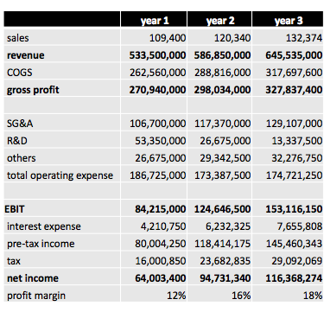

# 12. Key partners:

Supplier are usually those who can provide goods or services for a period of time conforming to standard terms and conditions. The relationship with suppliers is built through a single purchase order with clear-cut deliverables. However, our products involve uncertain factors such as features, technologies, timing, and costs. In other words, we need customized service in several areas such as technical advice, and product design. So conventional standard component provided suppliers may not meet our need. We need suppliers who can provide customized socket and transmitters. We are responsible for the final installation of total system.

As for the key partners, construction firm is a good choice. Our product has to be installed before the finishing layer of wall is applied. Construction firms play a role in not only implementation of product installation. Also, we can work together to design where the components inside the wall (transmitters) should be fixed. Building a good partnership with construction firm could help us promote our products.

# 13. Regulations:

There are two industry organizations for wireless charging:

(1) Wireless Power Consortium: Qi Standard.

(2) AirFuel Alliance (merged with A4WP & PMA in 2015): AirFuel Standard.

These standards cover regulation aspects including: charging distance, the compatibility of devices, power, frequency etc. Therefore, to be more widely recognized to the market and applied to a broader scale, our product must meet with these standards.

Besides, we can also make tailored products that fit into each country’s power standard (i.e.: 110V in U.S., 220V in China etc.)